|  |  |
| --- | --- |
| **Ex. No. 12**  **Date:07.07.2021** | **DICTIONARY – LEVEL 1** |

**AIM:**

To write a simple python program using Dictionary.

**PROGRAMMING BASE:**

* A dictionary is a mapping between some set of keys and values.
* Each key is associated with a value.
* The mapping of a key and value is called a key-value pair and together they form one item or element.
* The values in a dictionary are not unique and can be duplicated, but the keys in the dictionary are unique.
* The value of the key enclosed within square brackets is used to access the elements from a dictionary. An alternative method of accessing the elements is the get() method, which is used with the key.
* The difference between the accessing methods of dictionary is that when the key is not found in dictionary, it returns none instead of keyError.
* Dictionaries are mutable and thus the elements or values can be modified

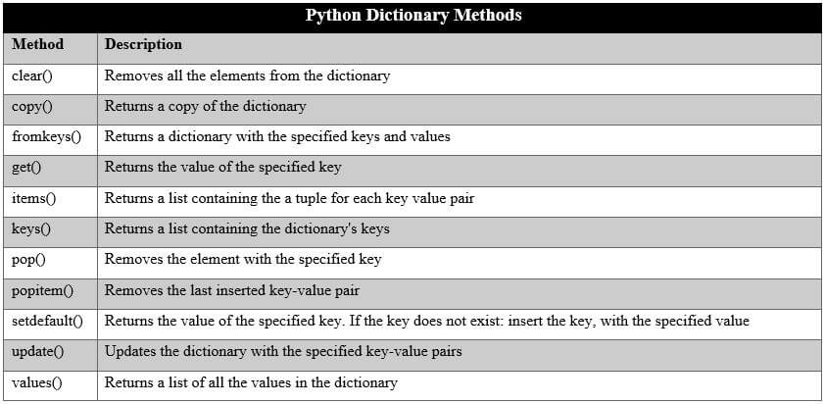

**PROGRAMS:**

**Description:**

Get the students mark in dictionary as given below:

stud = {'IT1001':98, 'IT1002':100, 'IT1003':78, 'IT1004':89}

Input Format:

First line denotes the number of entry in the dictionary

Further lines denotes the key and value

Output Format:

Display the message "Dictionary created successfully"

Constraints:

1. Limit should be positive value. If not display, "Please give positive value"

2. If limit is 0 then display "Sorry, no entry"

3. Mark should be between 0 to 100. If not display the message as "Mark should be between 0 to 100". The message should be display immediately if the mark does not satisfices the condition.

Sample Input:

4

IT1001

98

IT1002

100

IT1003

78

IT1004

89

Sample Output:

Dictionary created successfully

**Program:**

''' Name : R.sridevi

Roll Number : 20uit021

Program Name : Creating dictionary'''

n=int(input())

if n<0:

print('Please give positive value')

elif n==0:

print('Sorry, no entry')

else:

dict1={}

temp = 0

for i in range(n):

roll=input()

mark=int(input())

if mark>=0 and mark<=100:

dict1[roll]=mark

else:

print('Mark should be between 0 to 100')

temp=1

break

if temp==0:

print('Dictionary created successfully')

**Test Cases:**

|  |  |  |
| --- | --- | --- |
| **Test Case No.** | **Input** | **Expected Output** |
| 1 | 4  IT1001  98  IT1002  100  IT1003  78  IT1004  89 | Dictionary created successfully |
| 2 | -9 | Please give positive value |
| 3 | 0 | Sorry, no entry |
| 4 | 2  IT1001  89  IT1002  -8 | Mark should be between 0 to 100 |
| 5 | 1  IT1001  987 | Mark should be between 0 to 100 |
| **Total Test Cases** | | **5** |
| **Number of Test Cases Passed** | | **5** |

**RESULT:**

Thus, the Python programs are executed successfully.